A NAPT Proxy for Vulnerability Scanners based on Cloud
A Project Report submitted in partial fulfillment of the
requirements for the award of the degree of

Master Of Computer Application
In

Department Of Computer Applications
By

Neelam Suresh Babu
(23H71F0034)
Under the Esteemed Guidance of

Mrs. K.Harika
Assistant Professor


Department of Computer Applications

DVR & Dr. HS

MIC College of Technology
(Autonomous)
Kanchikacherla– 521180, NTR Dist., Andhra Pradesh May, 2025

DECLARATION

I here by declare that, the work contains in this report is original and has been done by me under the guidance of our supervisor Mrs.K. Harika. The work has not been submitted to any other Institute for obtaining any degree or diploma. I have followed the guidelines provided by the Institute in preparing the report. I have conformed to the norms and guidelines given in the Ethical Code of Conduct of the Institute. Whenever I have used materials (data, theoretical analysis, figures, and text) from other sources, I have given due credit to them by citing in the text of report and giving their details in the references.

Place: Kanchikacherla
Date:
N.SURESH BABU (23H71F0034)



CERTIFICATE

This is to certify that the project report entitled “A NAPT Proxy for Vulnerability Scanners Based on Cloud”submitted by N.SURESH BABU(23H71F0034) to the DVR & Dr. HS MIC College of Technology in partial fulfillment of the requirements for the award of the Degree of Master of Computer Application in is a bonafide record of work. The contents of this report, in full or in parts, have not been submitted to any other Institute for the award of any Degree.

- Supervisor Head of the Department

Principal

Internal Examiner External Examiner

ACKNOWLEDGEMENT

The satisfaction that accompanies the successful completion of any task would be incomplete without the mention of the people who made it possible
and whose constant guidance and engagement crown all the efforts with success. We thank our college management and respected Sri D. Panduranga Rao, CEO for providing us the necessary infrastructure to carry out the project work.
I would like to gratify my heart full thanks to the principal (Academics)
Dr. T. Vamsee Kiran who has been a great source of information for our work.

I would like to express my sincere thanks to Mrs. A. Anuradha, Head, Department of Computer Applications for extending her support to carry on this project work.

I am thankful to my Project Coordinator Mr. K. Mahanthi, Assistant Professor, Department of Computer Applications for their internal support and professionalism who helped me in shaping the project into successful one.

I would like to thank my project supervisor, Mrs. K. Harika, Assistant Professor, Department of Computer Applications for the guidance and support, especially for the valuable ideas and knowledge shared to me throughout the Project.

I take this opportunity to express my thanks to one and all who directly or indirectly helped me in bringing this effort to present form.
Finally, my special thanks go to my family for their continuous support and help throughout my academic years and for their continual support and encouragement for the completion of the project.

ABSTRACT

The rapid adoption of cloud computing has revolutionized the way organizations manage their IT infrastructure and security. One of the key advancements in this domain is the emergence of Security-as-a-Service (SaaS), an outsourcing model that allows organizations to leverage cloud-based solutions for security management. Among the various applications of SaaS, vulnerability scanners have gained significant traction due to their pay-per-use model and powerful scanning capabilities. These scanners enable organizations to identify and mitigate security vulnerabilities in their systems efficiently. However, deploying vulnerability scanners in cloud environments presents unique challenges. When performing vulnerability scans over a network, the scanner must establish a large number of TCP connections with the target hosts. In most organizational setups, these target hosts are deployed behind NAPT (Network Address and Port Translation) devices to address the IPv4 address shortage and to protect internal networks. While NAPT devices provide security and address conservation benefits, they also block external TCP connections, rendering cloud-based vulnerability scanners ineffective. To address this challenge, we propose Cloud Proxy, a NAPT proxy specifically designed for vulnerability scanners in cloud computing environments. Cloud Proxy combines the TURN (Traversal Using Relays around NAT) extension protocol and the Socks5 protocol to enable transparent packet relaying. By integrating the functionality of Socks5 into the TURN client, Cloud Proxy aggregates the destination ports of scanning packets before they pass through the TURN server.

LIST OF CONTENTS

CONTENTS PAGE NO
Title page I
Declaration II
Certificate III
Acknowledgment IV
Abstract V
List of Contents VII
Chapter 1: INTRODUCTION 1
  - System Overview 3
Chapter 2: LITERATURE SURVEY 5
Chapter 3: SYSTEM ANALYSIS 9
  - Introduction
3.2 Existing System
3.2.1Disadvantages Of Existing System

3.3 PROPOSED SYSTEM
3.3.1 Advantages of Proposed System

FEASIBILITY STUDY
3.4.1 Technical Feasibility
    - Economic Feasibility
3.4.3 Operational Feasibility

3.5 REQUIREMENT ANALYSIS

3.5.1 Functional Requirements
3.5.2 Non-Functional Requirements
CHAPTER 4: DEVELOPMENT ENVIRONMENT 23
4.1 USER REQUIREMENTS
4.1.1 Software Requirements
4.1.2 Hardware Requirements
4.2 PROGRAMING ENVIRONMENT
CHAPTER 5: DESIGN AND DEVELOPMENT
5.1 Introduction
5.2 Spiral Model
5.3 Database And Tables
5.4 Data Modeling
5.5 Modules
CHAPTER 6: TESTING AND VALIDATION 60-78
6.1 Types Of Testing
6.2 Types Of Tests
CHAPTER 7: SCREENSHOTS
CHAPTER 8: CONCLUSION
7.1 Feature Enhancement
CHAPTER 9: REFERENCES

INTRODUCTION

SYSTEM OVERVIEW

What is cloud computing?

Cloud computing is the use of computing resources (hardware and software) that are delivered as a service over a network (typically the Internet). The name comes from the common use of a cloud-shaped symbol as an abstraction for the complex infrastructure it contains in system diagrams. Cloud computing entrusts remote services with a user's data, software and computation. Cloud computing consists of hardware and software resources made available on the Internet as managed third-party services. These services typically provide access to advanced software applications and high-end networks of server computers.

How Cloud Computing Works?

The goal of cloud computing is to apply traditional supercomputing, or high-performance computing power, normally used by military and research facilities, to perform tens of trillions of
computations per second, in consumer-oriented applications such as financial portfolios, to deliver personalized information, to provide data storage or to power large, immersive computer games. The cloud computing uses networks of large groups of servers typically running low-cost consumer PC technology with specialized connections to spread data-processing chores across them. This shared IT infrastructure contains large pools of systems that are linked together. Often, virtualization techniques are used to maximize the power of cloud computing.

Characteristics and Services Models:

The salient characteristics of cloud computing based on the definitions provided by the National Institute of Standards and Terminology (NIST) are outlined below:

- On-demand self-service: A consumer can unilaterally provision computing capabilities, such as server time and network storage, as needed automatically without requiring human interaction with each service’s provider.
- Broad network access: Capabilities are available over the network and accessed through standard mechanisms that promote use by heterogeneous thin or thick client platforms (e.g., mobile phones, laptops, and PDAs).

- Resource pooling: The provider’s computing resources are pooled to serve multiple consumers using a multi-tenant model, with different physical and virtual resources dynamically assigned and reassigned according to consumer demand. There is a sense of location-independence in that the customer generally has no control or knowledge over the exact location of the provided resources but may be able to specify location at a higher level of abstraction (e.g., country, state, or data center). Examples of resources include storage, processing, memory, network bandwidth, and virtual machines.
- Rapid elasticity: Capabilities can be rapidly and elastically provisioned, in some cases automatically, to quickly scale out and rapidly released to quickly scale in. To the consumer, the capabilities available for provisioning often appear to be unlimited and can be purchased in any quantity at any time.
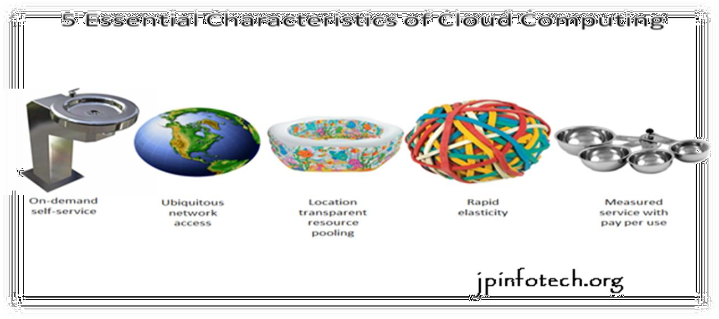
- Measured service: Cloud systems automatically control and optimize resource use by leveraging a metering capability at some level of abstraction appropriate to the type of service (e.g., storage, processing, bandwidth, and active user accounts). Resource usage can be managed, controlled, and reported providing transparency for both the provider and consumer of the utilized service.

Fig 1.2 Characteristics of cloud computing

Services Models:

Cloud Computing comprises three different service models, namely Infrastructure-as-a- Service (IaaS), Platform-as-a-Service (PaaS), and Software-as-a-Service (SaaS). The three service models or layer are completed by an end user layer that encapsulates the end user perspective on cloud services. The model is shown in figure below. If a cloud user accesses services on the infrastructure layer, for instance, she can run her own applications on the resources of a cloud infrastructure and remain responsible for the support, maintenance, and security of these applications herself. If she accesses a service on the application layer, these tasks are normally taken care of by the cloud service provider.

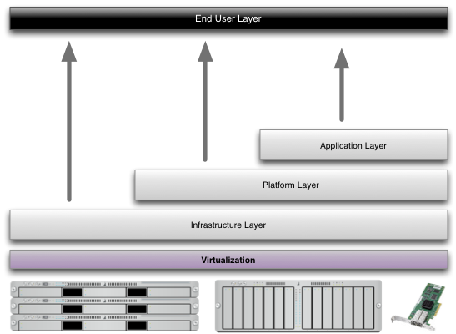

Fig 1.3 Structure of service models

Benefits of cloud computing:

    - Achieve economies of scale – increase volume output or productivity with fewer people. Your cost per unit, project or product plummets.
    - Reduce spending on technology infrastructure. Maintain easy access to your information with minimal upfront spending. Pay as you go (weekly, quarterly or yearly), based on demand.
    - Globalize your workforce on the cheap. People worldwide can access the cloud, provided they have an Internet connection.
    - Streamline processes. Get more work done in less time with less people.
    - Reduce capital costs. There’s no need to spend big money on hardware, software or licensing fees.
    - Improve accessibility. You have access anytime, anywhere, making your life so much easier!
    - Monitor projects more effectively. Stay within budget and ahead of completion cycle times.
    - Less personnel training is needed. It takes fewer people to do more work on a cloud, with a minimal learning curve on hardware and software issues.
    - Minimize licensing new software. Stretch and grow without the need to buy expensive software licenses or programs.
    - Improve flexibility. You can change direction without serious “people” or “financial” issues at stake.

Advantages:

- Price: Pay for only the resources used.
- Security: Cloud instances are isolated in the network from other instances for improved security.
- Performance: Instances can be added instantly for improved performance. Clients have access to the total resources of the Cloud’s core hardware.
- Scalability: Auto-deploy cloud instances when needed.
- Uptime: Uses multiple servers for maximum redundancies. In case of server failure, instances can be automatically created on another server.
- Control: Able to login from any location. Server snapshot and a software library lets you deploy custom instances.
- Traffic: Deals with spike in traffic with quick deployment of additional instances to handle the load.
CHAPTER 2
LITERATURE SURVEY

TITLE: Secure Text Transfer in Cloud
AUTHOR K. Antony Kumar:
https://ieeexplore.ieee.org/document/9755879
This paper addresses the challenge of secure text transfer in cloud environments, a critical concern in the fields of data security, IoT, and cloud computing. The author conducts a detailed literature review to identify existing gaps and formulates research objectives aligned with current technological trends. The proposed system is designed to solve specific challenges such as secure data sharing in cloud environments using innovative techniques and methodologies. The research contributes significantly to the field of Computer Science and Engineering by introducing novel approaches that enhance security and efficiency. The study highlights that while the proposed solution introduces notable innovations, it also has potential applications in various domains such as healthcare, finance, and education. However, like many advanced systems, it faces limitations regarding scalability and resource management when handling large datasets or numerous users. The paper concludes by emphasizing the importance of enhancing scalability and exploring advanced technologies such as quantum computing and deep learning to further optimize the system and ensure robust, secure text transfer in increasingly complex cloud environments.

Zhao Li: Massive XML Data Mining in Cloud Computing Environment

https://ieeexplore.ieee.org/author/37597745900
This paper addresses the challenge of mining useful information from massive XML documents within a cloud computing environment. The author adopts a detailed methodology involving the analysis of cloud computing structures and XML tree data models. It focuses on the distributed nature of cloud computing and its capability to manage large-scale XML data processing. Additionally, it examines the tree-based structure of XML documents, particularly the hierarchical relationships among elements, attributes, and nodes, while identifying challenges such as data redundancy, complex nested structures, and query performance issues. The proposed system concentrates on efficiently extracting valuable information from large XML datasets. The structure of the cloud computing environment and the corresponding tree data model of XML documents are pre-analyzed. The system's architecture is composed of three main layers: the "Application Layer," the "Data Processing Layer," and the "XML Data Converting Layer," enabling systematic handling and mining of XML data. Although the paper contributes to advancements in the field of Computer Science and Engineering by introducing structured approaches for large-scale XML data mining, it acknowledges that its applications are particularly suited to specific domains such as healthcare, finance, and education. In conclusion, the paper demonstrates that the proposed methodology is effective in mining useful information from massive XML documents in cloud computing environments with high efficiency. Experimental results reinforce the system's capability to address data mining challenges with improved performance.

Jiang, X. Chen, L. Chen: A Vulnerability Scanning Framework Based on Monitoring Agents for IaaS Platforms
https://ieeexplore.ieee.org/author/37086375301
This paper introduces a real-time vulnerability scanning framework specifically designed for Infrastructure-as-a-Service (IaaS) platforms. The methodology involves the deployment of distributed lightweight monitoring agents across virtual machines (VMs), containers, and network devices. These agents continuously collect data regarding system configurations, network traffic, and security policies. Collected data is encrypted and securely transmitted to a centralized vulnerability assessment engine, ensuring safe and efficient data handling. The proposed system leverages distributed monitoring agents that track system behavior dynamically to detect vulnerabilities in real time. The framework integrates seamlessly with existing cloud security solutions, providing continuous and proactive risk assessments instead of relying on traditional periodic scanning methods. While the research significantly contributes to advancements in Computer Science and Engineering by introducing a dynamic, real-time vulnerability detection method, it highlights its strongest applications in domains such as healthcare, finance, and education where real-time data security is critical. In conclusion, the proposed real-time vulnerability scanning framework enhances cloud security by providing continuous, dynamic risk assessments. Unlike conventional methods, this system leverages real-time monitoring agents and threat correlation techniques to proactively detect vulnerabilities and enhance the security posture of IaaS environments.

CHAPTER 3

SYSTEM STUDY AND ANALYSIS

3.1 INTRODUCTION

After analyzing the requirements of the task to be performed, the next step is to analyze the problem and understand its context. The first activity in the phase is studying the existing system and other is to understand the requirements and domain of the new system. Both the activities are equally important, but the first activity serves as a basis of giving the fundamental specifications and then successful design of the proposed system. Understanding the properties and requirements of a new system is more difficult and requires creative thinking and understanding of existing running system is difficult, improper understanding of the present system can lead diversion from solution.

EXISTING SYSTEM
- In traditional systems, vulnerability scanners are deployed in cloud computing environments to assess the security of target hosts. These scanners typically establish numerous TCP connections to carry out the scanning process, sending packets over the network to identify vulnerabilities. However, several challenges arise in this setup, especially in scenarios involving NAPT (Network Address and Port Translation) devices, which are commonly used to protect internal networks.
- NAPT Device Interference: NAPT devices are used to map private IP addresses to public IP addresses. This creates a challenge for vulnerability scanners because any outgoing TCP packets from the scanner may be blocked by the NAPT device, preventing successful communication between the scanner and the target hosts.
- Poor TCP Support in NAPT Traversal: While NAPT traversal methods exist, most of them support UDP traffic well but are inadequate for handling the numerous TCP connections required by vulnerability scanners in cloud computing environments.
- Lack of Seamless Integration: There is no direct or efficient mechanism for ensuring vulnerability scanning tools can function smoothly through NAPT or other network address translation methods, leading to unreliable and incomplete vulnerability scans.

Disadvantages Of Existing System:
Inability to Complete Scanning Tasks:
NAPT Device Interference: Since NAPT devices map private IP addresses to public ones, they can block outgoing TCP packets from the vulnerability scanner.

Ineffective NAPT Traversal for TCP Traffic:
Poor TCP Support: Most NAPT traversal methods are optimized for UDP traffic, not TCP. Given that vulnerability scanners rely on establishing numerous TCP connections to carry out scans, existing traversal methods struggle to accommodate the volume and complexity of TCP traffic.

Performance Degradation:
High Latency and Packet Loss: Due to inefficient traversal of NAPT devices and poor support for TCP, the process of relaying packets through the network becomes slower.

PROPESED SYSTEM:
To address the above challenges, the proposed system introduces Cloud Proxy, a NAPT proxy designed to allow vulnerability scanners to operate effectively in cloud environments despite NAPT-related limitations. Cloud Proxy is built by combining the TURN extension protocol and the Socks5 protocol, creating a solution that can efficiently relay scanning packets through NAPT devices.

1TURN Protocol:
- Facilitates packet relaying through NAT devices by acting as an intermediary server.
- Ensures that packets from the vulnerability scanner reach the target host behind the NAPT device.

Socks5 Protocol:
- Provides a proxy layer for handling TCP connections.
- Integrated into the TURN client to aggregate scanning packets and reduce the load on the TURN server.

TURN Client with Socks5 Integration:
- Combines the functionality of Socks5 and TURN to optimize packet handling
- Aggregate’s destination ports of scanning packets before relaying them to the TURN.

3.3.1 Advantages of Proposed System:
NAPT Traversal for TCP Connections:
1.Enables vulnerability scanners to establish TCP connections with targets behind NAPT devices, overcoming the limitations of existing NAPT traversal methods.

Transparent Packet Relaying:
1.Ensures that scanning packets are relayed seamlessly without requiring changes to the target host or the scanner.

Scalability:
- Handles a large number of TCP connections efficiently, making it suitable for real- world vulnerability scanning scenarios.

Reduced TURN Server Load:
- By aggregating packets at the

FEASIBILITY STUDY
To manner studies and explores of an active and scientific nature and to encourage the conversation and enlargement of approaches and tools for operational analysis is useful to protection problems.
Feasibility study is accompanied once the difficult is obviously understood. The feasibility study which is a great level lozenge version of the whole system analysis and design procedure. The independent is to define whether the planned system is possible or not and it benefits us to the least expense of how to resolve the problem and to govern, if the Problem is wealth solving.
The following are the three important tests that have been conceded out for feasibility study.
- Technical Feasibility
- Economic feasibility
- Operational feasibility

Technical feasibility
In the technical feasibility study, one has to assess whether the implemented system can be established using existing technology or not. It is intended to implement the implemented system in JSP. The project enabled is theoretically feasible since the following reasons.
      - All needed technology exists to improve the system.
      - The existing system is so malleable that it can be advanced further.

Economic feasibility
As a portion of this, the expenses and profits related with the implemented systems are to be associated. The project is carefully feasible only if tangible and intangible assistances balance the cost. We can say the implemented system is feasible founded on the following grounds.
- The charge of developing the filled system is sensible.
- The cost of hardware and software for the application is less.

Operational feasibility
This project is operationally feasible for there is necessary support from the project organization and the users of the implemented system. Implemented system absolutely does not damage and determination not create the corrupt results and no problem will ascend after implementation of the system.

REQUIREMENT ANALYSIS

3.5.1Functional Requirements:
The model that is being followed is the SOFTWARE DEVELOPMENT LIFE CYCLE MODEL, which states that the phases are organized in order. First of all the feasibility study is done. Once that part is completed, the requirement analysis and project planning begins. If system exists once, then modifications and addition of new modules is needed, analysis of present system can be used as basic model.
The design starts after the requirement analysis is completed and the coding begins after the design is completed. Once the programming is completed, the testing is done. In this model the sequence of activities performed in a software development project are
- Project planning
- Requirement definition
- Design
- Development
- Integration and testing
- Installation and acceptance

INPUT DESIGN
The input design is the link between the information system and the user. It comprises the developing specification and procedures for data preparation and those steps are necessary to put transaction data in to a usable form for processing can be achieved by inspecting the computer to read data from a written or printed document or it can occur by having people keying the data directly into the system. The design of input focuses on controlling the amount of input required, controlling the errors, avoiding delay, avoiding extra steps and keeping the process simple. The input is designed in such a way so that it provides security and ease of use with retaining the privacy. Input Design considered the following things:
- What data should be given as input?
- How the data should be arranged or coded?
- The dialog to guide the operating personnel in providing input.
- Methods for preparing input validations and steps to follow when error occur.

OBJECTIVES
- Input Design is the process of converting a user-oriented description of the input into a computer- based system. This design is important to avoid errors in the data input process and show the correct direction to the management for getting correct information from the computerized system.
- It is achieved by creating user-friendly screens for the data entry to handle large volume of data. The goal of designing input is to make data entry easier and to be free from errors. The data entry
screen is designed in such a way that all the data manipulates can be performed. It also provides record viewing facilities.
- When the data is entered it will check for its validity. Data can be entered with the help of screens.
Appropriate messages are provided as when needed so that the user
will not be in maize of instant. Thus, the objective of input design is to create an input layout that is easy to follow

OUTPUT DESIGN

A quality output is one, which meets the requirements of the end user and presents the information clearly. In any system results of processing are communicated to the users and to other system through outputs. In output design it is determined how the information is to be displaced for immediate need and also the hard copy output. It is the most important and direct source information to the user. Efficient and intelligent output design improves the system’s relationship to help user decision-making.
- Designing computer output should proceed in an organized, well thought out manner; the right output must be developed while ensuring that each output element is designed so that people will find the system can use easily and effectively. When analysis design computer output, they should Identify the specific output that is needed to meet the requirements.
- Select methods for presenting information.
- Create document, report, or other formats that contain information produced by the system.
The output form of an information system should accomplish one or more of the following objectives.
- Convey information about past activities, current status or projections of the
- Future.
- Signal important events, opportunities, problems, or warnings.
- Trigger an action.
- Confirm an action.

Non-functional requirements:
The major non-functional requirements of the system are as follows

User-friendly
Customer will use the forms for their various transactions i.e. for adding new routes, viewing the routes details. Also the Customer wants the reports to view the various transactions based on the constraints. These forms and reports are generated as user-friendly to the Client.

Reliability
The package wills pick-up current transactions on line. Regarding the old transactions, User will enter them in to the system.

Security
The web server and database server should be protected from hacking, virus etc.
Security is freedom from, or resilience against, potential harm caused by others. Beneficiaries of security may be of persons and social groups, objects and institutions, ecosystems or any other entity or phenomenon vulnerable to unwanted change by its environment.

Availability
This software will be available always. High availability software is software used to ensure that systems are running and available most of the time. High availability is a high percentage of time that the system is functioning. It can be formally defined as

CHAPTER 4 DEVELOPMENT ENVIRONMENT

User Requirements
Requirement Specification plays an important role to create quality software solution. Requirements are refined and analyzed to assess the clarity. Requirements are represented in a manner that ultimately leads to successful software implementation. Each requirement must be consistent with the overall objective.

Software Requirements
The software requirements specification is produced at the end of the analysis task. Software requirement is a difficult task, only decided after testing whether it fits the requirements.
Operating System - Windows XP
Coding Language - python
Front End - HTML5, CSS, JavaScript
Back End - MySQL

4.1.2Hardware Requirements
This is a java project so hardware plays an important role. Selection of hardware also plays an important role in existence and performance of any software. The size and capacity are main requirements.
Processor - Pentium –IV
RAM - 4 GB (min)
Hard Disk - 20 GB
Key Board - Standard Windows Keyboard
Mouse - Two or Three Button Mouse
Monitor - SVGA

4.2 Programming Environment in Python
- Programming Language
Python 3.8+
Python is chosen for its readability and large ecosystem of cryptographic libraries.
- Libraries Required
Here are the primary Python libraries you'll need:
  - Charm-Crypto
A Python library for rapid prototyping of advanced cryptosystems using pairing-based and lattice-based cryptography.
- Install:

bash Copy Edit
pip install charm-crypto
  - pycryptodome
A self-contained Python package of low-level cryptographic primitives. Used for additional encryption/hashing if needed.
- Install:
bash Copy
Edit
pip install pycryptodome
  - hashlib (Standard Library)
For standard hash functions (SHA-256, SHA-3, etc.

- Development Environment Setup
    - IDE
VSCode, PyCharm, or Jupiter Notebook are recommended. You can enable extensions for Python linting and debugging.
    - Operating System
Compatible across Linux, macOS, and Windows. Linux is typically preferred for crypto dev due to better performance and compatibility.
    - Dependencies Setup Create a virtual environment:
bash Copy Edit
python -m venv dedup_env
source dedup_env/bin/activate # Linux/macOS dedup_env\Scripts\activate # Windows Install requirements:
bash Copy Edit
pip install charm-crypto pycryptodome
◻ Key Components to Implement in Python
Here’s a mapping of the algorithms from the paper to what you’d implement:
Paper Algorithm Python Implementation Idea
Setup(k) Generate group parameters using Charm's pairing group FileKey Hash file, derive private/public keys
UserKey Generate random scalar a, compute public key g^a ReKey Calculate g^{a·f} for re-encryption

FileTag Use random scalar r, calculate (g^r, H3(e(w, g^{rf}))) Enc Encrypt file as (g^r, F * Z^{f·r})
TestTag Hash-based test tag
Test Equality check using pairing comparison ReEnc Re-encrypt using stored rekey ReDec Decrypt using private key
◻ Example: Setup with Charm-Crypto python
Copy Edit
from charm.toolbox.pairinggroup import PairingGroup, G1, G2, ZR, pair group = PairingGroup('SS512') # Symmetric pairing (like Type A in JPBC)
# Public parameters
g = group.random(G1) Z = pair(g, g)
This initializes the pairing group and sets up the environment for public key encryption

NetworkingTCP/IP stack

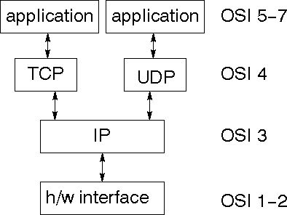
The TCP/IP stack is shorter than the OSI one:

Fig 3.6 networking TCP/IP
TCP is a connection-oriented protocol; UDP (User Datagram Protocol) is a connectionless protocol.

IP datagram’s

The IP layer provides a connectionless and unreliable delivery system. It considers each datagram independently of the others. Any association between datagram must be
supplied by the higher layers. The IP layer supplies a checksum that includes its own header. The header includes the source and destination addresses. The IP layer handles routing through an Internet. It is also responsible for breaking up large datagram into smaller ones for transmission and reassembling them at the other end.
UDP
UDP is also connectionless and unreliable. What it adds to IP is a checksum for the contents of the datagram and port numbers. These are used to give a client/server model
- see later.
TCP
TCP supplies logic to give a reliable connection-oriented protocol above IP. It provides a virtual circuit that two processes can use to communicate.

Internet addresses
In order to use a service, you must be able to find it. The Internet uses an address scheme for machines so that they can be located. The address is a 32 bit integer which gives the IP address. This encodes a network ID and more addressing. The network ID falls into various classes according to the size of the network address.

Network address
Class A uses 8 bits for the network address with 24 bits left over for other addressing. Class B uses 16 bit network addressing. Class C uses 24 bit network addressing and class D uses all 32.

Subnet address

Internally, the UNIX network is divided into sub networks. Building 11 is currently on one sub network and uses 10-bit addressing, allowing 1024 different hosts.

Host address

8 bits are finally used for host addresses within our subnet. This places a limit of 256 machines that can be on the subnet.

Total address


Fig 3.7 total address

The 32 bit address is usually written as 4 integers separated by dots.

Port addresses

A service exists on a host, and is identified by its port. This is a 16 bit number. To send a message to a server, you send it to the port for that service of the host that it is running on. This is not location transparency! Certain of these ports are "well known".

Sockets

A socket is a data structure maintained by the system to handle network connections. A socket is created using the call socket. It returns an integer that is like a file descriptor. In fact, under Windows, this handle can be used with Read File and Write File functions.
#include <sys/types.h> #include <sys/socket.h>
int socket (int family, int type, int protocol);

Here "family" will be AF_INET for IP communications, protocol will be zero, and type will depend on whether TCP or UDP is used. Two processes wishing to communicate over a network create a socket each. These are similar to two ends of a pipe
- but the actual pipe does not yet exist.

JFree Chart

JFreeChart is a free 100% Java chart library that makes it easy for developers to display professional quality charts in their applications. JFreeChart's extensive feature set includes:
A consistent and well-documented API, supporting a wide range of chart types;
A flexible design that is easy to extend, and targets both server-side and client-side applications;
Support for many output types, including Swing components, image files (including PNG and JPEG), and vector graphics file formats (including PDF, EPS and SVG);
JFreeChart is "open source" or, more specifically, free software. It is distributed under the terms of the GNU Lesser General Public Licence (LGPL), which permits use in proprietary applications.

Map Visualizations
Charts showing values that relate to geographical areas. Some examples include:
(a) population density in each state of the United States, (b) income per capita for each country in Europe, (c) life expectancy in each country of the world. The tasks in this project include:
Sourcing freely redistributable vector outlines for the countries of the world, states/provinces in particular countries (USA in particular, but also other areas);
Creating an appropriate dataset interface (plus default implementation), a rendered, and integrating this with the existing XYPlot class in JFreeChart;
Testing, documenting, testing some more, documenting some more.

Time Series Chart Interactivity

Implement a new (to JFreeChart) feature for interactive time series charts --- to display a separate control that shows a small version of ALL the time series data, with a sliding "view" rectangle that allows you to select the subset of the time series data to display in the main chart.

Dashboards

There is currently a lot of interest in dashboard displays. Create a flexible dashboard mechanism that supports a subset of JFreeChart chart types (dials, pies, thermometers, bars, and lines/time series) that can be delivered easily via both Java Web Start and an applet.

Property Editors

The property editor mechanism in JFreeChart only handles a small subset of the properties that can be set for charts. Extend (or reimplement) this mechanism to provide greater end-user control over the appearance of the charts.
◻ Choosing a Database
For prototyping and ease of integration with Python:

✅Recommended:
SQLite (lightweight, serverless, ideal for simulation or local storage)

PostgreSQL or MySQL (for production or networked systems)

We’ll use SQLite here for demonstration because:

It’s built into Python (sqlite3)

No setup required

Good for testing and local simulation

- Database Schema Design Here’s a basic schema for SQLite:
- 1. users table

Field Type Description
id INTEGER Primary key username TEXT Unique user identifier public_key TEXT User's public key PKu
private_key TEXT Stored locally or encrypted
- 2. files table

Field Type Description
id INTEGER Primary key file_hash TEXT Unique hash of file content
ciphertext TEXT Encrypted file C = (C1, C2) tag_t1 TEXT Tag part T1 = g^r
tag_t2 TEXT Tag part T2 = H3(e(w, g^rf))
- 3. re_encryption_keys table

Field Type Description
id INTEGER Primary key

file_id INTEGER Foreign key from files table user_id INTEGER Foreign key from users table rk TEXT Re-encryption key RKF→u = g^(a·f)
- SQLite Connection in Python python
Copy Edit
import sqlite3

# Connect to the database (or create it) conn = sqlite3.connect('dedup_db.sqlite') cursor = conn.cursor()
- Creating the Tables python
Copy Edit
def create_tables(): cursor.execute('''
CREATE TABLE IF NOT EXISTS users (
id INTEGER PRIMARY KEY AUTOINCREMENT,
username TEXT UNIQUE, public_key TEXT, private_key TEXT
)
''')

cursor.execute('''

CREATE TABLE IF NOT EXISTS files (
id INTEGER PRIMARY KEY AUTOINCREMENT,
file_hash TEXT UNIQUE, ciphertext TEXT,
tag_t1 TEXT, tag_t2 TEXT
)
''')

cursor.execute('''
CREATE TABLE IF NOT EXISTS re_encryption_keys ( id INTEGER PRIMARY KEY AUTOINCREMENT,
file_id INTEGER, user_id INTEGER, rk TEXT,
FOREIGN KEY (file_id) REFERENCES files(id), FOREIGN KEY (user_id) REFERENCES users(id)
)
''')

conn.commit()
- Sample Use: Inserting and Retrieving Data Insert a user:
python Copy Edit
def insert_user(username, pk, sk):

cursor.execute("INSERT INTO users (username, public_key, private_key) VALUES (?, ?, ?)", (username, pk, sk))
conn.commit() Insert a file and tag:
python Copy Edit
def insert_file(file_hash, ciphertext, t1, t2):
cursor.execute("INSERT INTO files (file_hash, ciphertext, tag_t1, tag_t2) VALUES (?, ?, ?,
?)",
(file_hash, ciphertext, t1, t2)) conn.commit()
Insert a re-encryption key:
python Copy Edit
def insert_re_encryption_key(file_id, user_id, rk):
cursor.execute("INSERT INTO re_encryption_keys (file_id, user_id, rk) VALUES (?, ?, ?)", (file_id, user_id, rk))
conn.commit()
✅Final Touch: Closing Connection python
Copy Edit
def close_db(): conn.close()

CHAPTER 5

DESIGN AND DEVELOPMENT

INTRODUCTION
The most creative and challenging phase of the life cycle is system and design. The term design describes a final system and the process by which it is developed. It refer to the technical specifications that will be applied in implementation the candidate system. The design may be defined as “the process of applying various techniques and principles for the purpose of defining a device, a process or a system in sufficient details to permit its physical realization”.
The design’s goal is how the output is to be produced and in what format samples of the output and input are also presented. Second input data and database files have to be designed to meet the requirements of the proposed output. The processing phase is handled through the program construction and testing. Finally details related to justification of the system and an estimate of the impact of the candidate system on the users and the organization are documented and evaluated by management as a step toward implementation.
The importance of software design can be stated in a single word “Quality”. Design provides us with representation of software that can be assessed for quality. Design is the only way that we can accurately translate a customer’s requirements into a finished software product or system without design we risk building an unstable system, that might fail it small changes are made or may be difficult to test, or one who’s quality can’t be tested. So it is an essential phase in the development of a software product.

SPIRAL MODEL SDLC METHODOLOGY
The document ply vital role in the development of life cycle (SDLC) as it describes the complete requirement of the system. It means for use by developers and will be the basic during testing phase. Any changes made to the requirements in the future will have to go through formal change approval process.

SPIRAL MODEL was defined by Barry Boehm in his 1988 article, “A spiral model of Software Development and Enhancement.
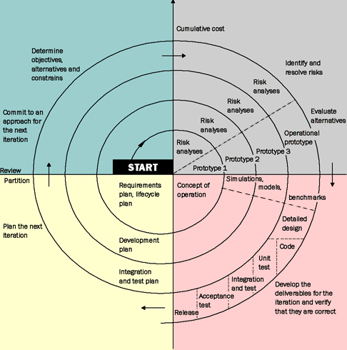

FIG :4.1 SDLC METHODOLOGY

Advantages of Spiral model:
- High amount of risk analysis hence, avoidance of Risk is enhanced.
- Good for large and mission-critical projects.
- Strong approval and documentation control.
- Additional Functionality can be added at a later date.
- Software is produced early in the software life cycle.

Disadvantages of Spiral model:

- Can be a costly model to use.
- Risk analysis requires highly specific expertise.
- Project’s success is highly dependent on the risk analysis phase.
- Doesn’t work well for smaller projects.

When to use Spiral model:

- When costs and risk evaluation is important
- For medium to high-risk projects
- Long-term project commitment unwise because of potential changes to economic priorities
- Requirements are complex
- New product line.
- Significant changes are expected (research and exploration).

DATABASE AND TABLES:

A database management system (DBMS) is computer software designed for the purpose of managing databases, a large set of structured data, and run operations on the data requested by numerous users. Typical examples of DBMSs include Oracle, DB2, Microsoft Access, Microsoft SQL Server, Firebird, PostgreSQL, MySQL, SQLite, FileMaker and Sybase Adaptive Server Enterprise. DBMSs are typically used by Database administrators in the creation of Database systems. Typical examples of DBMS use include accounting, human resources and customer support systems.
Originally found only in large companies with the computer hardware needed to support large data sets, DBMSs have more recently emerged as a fairly standard part of any company back office.

Description:
A DBMS is a complex set of software programs that controls the organization, storage, management, and retrieval of data in a database. A DBMS includes:
- A modeling language to define the schema of each database hosted in the DBMS, according to the DBMS data model.
  - The four most common types of organizations are the hierarchical, network, relational and object models. Inverted lists and other methods are also used. A given database management system may provide one or more of the four models. The optimal structure depends on the natural organization of the application's data, and on the application's requirements (which include transaction rate (speed), reliability, maintainability, scalability, and cost).
  - The dominant model in use today is the ad hoc one embedded in SQL, despite the objections of purists who believe this model is a corruption of the relational model, since it violates several of its fundamental principles for the sake of practicality and performance. Many DBMSs also support the Open Database Connectivity API that supports a standard way for programmers to access the DBMS.
- Data structures (fields, records, files and objects) optimized to deal with very large amounts of data stored on a permanent data storage device (which implies relatively slow access compared to volatile main memory).
- A database query language and report writer to allow users to interactively interrogate the database, analyze its data and update it according to the users privileges on data.
  - It also controls the security of the database.
  - Data security prevents unauthorized users from viewing or updating the database. Using passwords, users are allowed access to the entire database or subsets of it called subschemas. For example, an employee database can contain all the data about an individual employee, but one group of users may be authorized to view only payroll data, while others are allowed access to only work history and medical data.
  - If the DBMS provides a way to interactively enter and update the database, as well as interrogate it, this capability allows for managing personal databases.
- A transaction mechanism, that ideally would guarantee the ACID properties, in order to ensure data integrity, despite concurrent user accesses (concurrency control), and faults (fault tolerance).
  - It also maintains the integrity of the data in the database.
  - The DBMS can maintain the integrity of the database by not allowing more than one user to update the same record at the same time. The DBMS can help prevent duplicate records via unique index constraints; for example, no two customers with the same customer numbers (key fields) can be entered into the database. See ACID properties for more information (Redundancy avoidance).
The DBMS accepts requests for data from the application program and instructs the operating system to transfer the appropriate data.
When a DBMS is used, information systems can be changed much more easily as the organization's information requirements change. New categories of data can be added to the database without disruption to the existing system.
Organizations may use one kind of DBMS for daily transaction processing and then move the detail onto another computer that uses another DBMS better suited for random inquiries and analysis. Overall systems design decisions are performed by data administrators and systems analysts. Detailed database design is performed by database administrators.
Database servers are specially designed computers that hold the actual databases and run only the DBMS and related software. Database servers are usually multiprocessor computers, with RAID disk arrays used for stable storage. Connected to one or more servers via a high-speed channel, hardware database accelerators are also used in large volume transaction processing environments.
DBMSs are found at the heart of most database applications. Sometimes DBMSs are built around a private multitasking kernel with built-in networking support although nowadays these functions.

SQL
Structured Query Language (SQL) is the language used to manipulate relational databases. SQL is tied very closely with the relational model.
In the relational model, data is stored in structures called relations or tables.

SQL statements are issued for the purpose of:

Data definition: Defining tables and structures in the database (DDL used to create, alter and drop schema objects such as tables and indexes).
Data manipulation: Used to manipulate the data within those schema objects (DML Inserting, Updating, Deleting the data, and Querying the Database).
A schema is a collection of database objects that can include: tables, views, indexes and sequences List of SQL statements that can be issued against an Oracle database schema are:
- ALTER - Change an existing table, view or index definition (DDL)
- AUDIT - Track the changes made to a table (DDL)
- COMMENT - Add a comment to a table or column in a table (DDL)
- COMMIT - Make all recent changes permanent (DML - transactional)
- CREATE - Create new database objects such as tables or views (DDL)
- DELETE- Delete rows from a database table (DML)
- DROP - Drop a database object such as a table, view or index (DDL)
- GRANT - Allow another user to access database objects such as tables or views (DDL)
- INSERT - Insert new data into a database table (DML)
- No AUDIT - Turn off the auditing function (DDL)
- REVOKE - Disallow a user access to database objects such as tables and views (DDL)
- ROLLBACK - Undo any recent changes to the database (DML - Transactional)
- SELECT - Retrieve data from a database table (DML)
- TRUNCATE - Delete all rows from a database table (can not be rolled back) (DML)
- UPDATE- Change the values of some data items in a database table (DML)

4.3 DFD/ER/UML DIAGRAM
The overall logical structure of a database can be expressed graphically by an E-R diagram.
The relative simplicity and pictorial clarity of this diagramming technique may well account in
large part for the widespread use of the E-R model. Such a diagram consists of the following major components.
Rectangles: Represent Entity Sets.

Ellipses: Represent attributes.

Diamonds: Represent relationship sets

Lines: Link attributes to entity sets and entity sets

DATA MODELING DFD DIAGRAM
- The DFD is also called as bubble chart. It is a simple graphical formalism that can be used to represent a system in terms of input data to the system, various processing carried out on this data, and the output data is generated by this system.
- The data flow diagram (DFD) is one of the most important modeling tools. It is used to model the system components. These components are the system process, the data used by the process, an external entity that interacts with the system and the information flows in the system.
- DFD shows how the information moves through the system and how it is modified by a series of transformations. It is a graphical technique that depicts information flow and the transformations that are applied as data moves from input to output.
- DFD is also known as bubble chart. A DFD may be used to represent a system at any level of abstraction. DFD may be partitioned into levels that represent increasing information flow and functional detail.

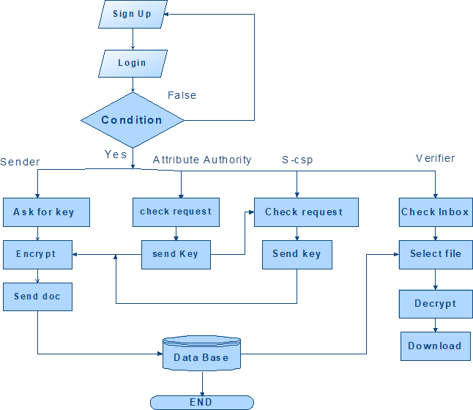
Fig:4.1DFD diagram

UML DIAGRAMS

Introduction to UML
UML is a method for describing the system architecture in detail using the blue print. UML implies a gathering of best building watches that have affirmed effective in the displaying of enormous and troublesome frameworks. The UML is an exceptionally noteworthy piece of creating articles situated programming and the product improvement process. The UML utilizes

for the most part graphical documentations to positive the outline of programming tasks. Spending the UML tasks groups interconnect, find potential plans, and approve the structural configuration of the product.
Definition: UML is a general purpose visual modeling language that is used to specify,visualize, construct, and document the artifacts of the software system.
UML is a language: It will provide vocabulary and rules for communications and function on conceptual and physical representation. So it is modeling language.
UML Specifying: Specifying means building models that are precise, unambiguous and complete. In particular, the UML address the specification of all the important analysis, design and implementation decisions that must be made in developing and displaying a software intensive system.
UML Visualization: The UML includes both graphical and textual representation. It makes easy to visualize the system and for better understanding.
UML Constructing: UML models can be directly connected to a variety of programming languages and it is sufficiently expressive and free from any ambiguity to permit the direct execution of models.
UML Documenting: UML provides variety of documents in addition raw executable codes.

Uses of UML:
The UML is intended primarily for software intensive systems. It has been used effectively for such domain as
1 .Enterprise Information System
- Banking and Financial Services
- Telecommunications
- Transportation
- Defense/Aerospace
- Retails
- Medical Electronics
- Scientific Fields
- Distributed Web

Rules of UML:
The UML has semantic rules for
- SCOPE: The content that gives specific meaning to a name.
- NAMES: It will call things, relationships and diagrams
- VISIBILITY: How those names can be seen and used by others.
- INTEGRITY: How things properly and consistently relate to another.
- EXECUTION: What it means is to run or simulate a dynamic model.

Building blocks of UML:
The vocabulary of the UML encompasses 3 kinds of building blocks
- Things
- Relationships
- Diagrams

Things:
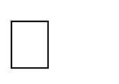
Things are the data abstractions that are first class citizens in a model. Things are of 4 types Structural Things


Behavioral Things Grouping Things

An notational Things

Relationships:

Relationships tie the things together. Relationships in the UML are Dependency

Association


Generalization Specialization

UML Diagrams:

Diagrams in the UML are of 2 types Static or Structural Diagrams

Static:
Dynamic or Behavioral Diagrams





Class diagrams Object diagrams. Component diagrams.

Dynamic:
Deployment diagrams



Use Case diagram.




Sequence diagram Collaboration diagram. State Chart diagram.

Activity diagram.

CLASS DIAGRAM:
In software engineering, a class diagram in the Unified Modeling
Language (UML) is a type of static structure diagram that describes the structure of a system by showing the system's classes, their attributes, operations (or methods), and the relationships among the classes. It explains which class contains information.

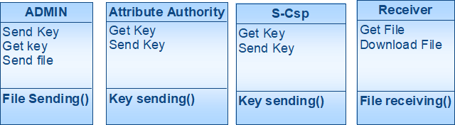

Fig. 4.2 Class Diagram

USE CASE DIAGRAM:
A use case diagram in the Unified Modeling Language (UML is a kind of behavioral outline positive by and produced using a Use-contextual investigation. Its determination is to surviving a graphical sign of the usefulness giving by a framework regarding performing artists and their points (spoke to as use cases), and any conditions between those utilization cases. The key reason for an utilization case outline is to show what framework capacities are performed for which on-screen character. Parts of the on-screen characters in the framework can be delineated.

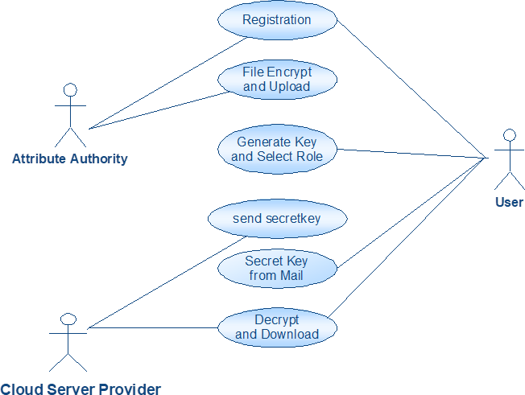

Fig.4.3 Use case Diagram

Sequence Diagram
A sequence diagram in Unified Modeling Language (UML) is a kind of interaction diagram that shows how processes operate with one another and in what order. It is a construct of a Message Sequence Chart. Sequence diagrams are sometimes called event diagrams, event scenarios, and timing diagrams.

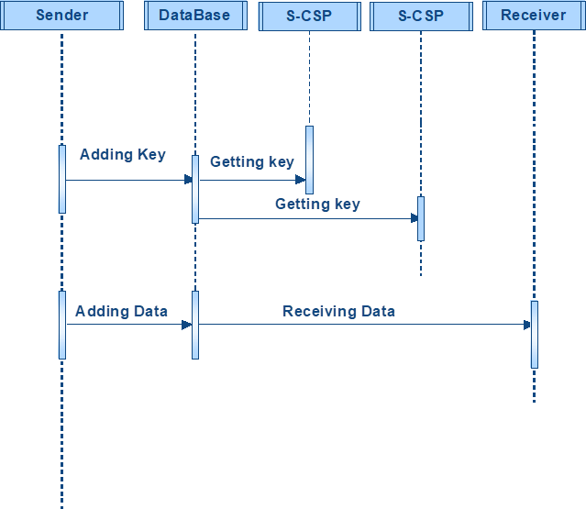

fig 4.4 sequence diagram

Activity Diagram:
Activity diagrams are graphical representations of workflows of stepwise activities and actions with support for choice, iteration and concurrency. In the Unified Modeling Language, activity diagrams can be used to describe the business and operational step-by-step workflows of components in a system. An activity diagram shows the overall flow of control.

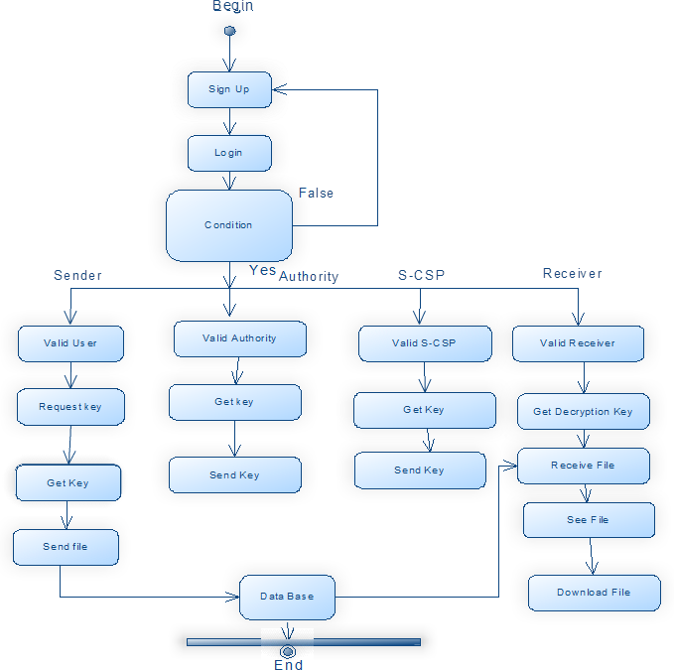

Fig 4.5 activity diagram

4.5MODULES

Implementation is the stage of the project when the theoretical design is turned out into a working system. Thus it can be considered to be the most critical stage in achieving a successful new system and in giving the user, confidence that the new system will work and be effective.
The implementation stage involves careful planning, investigation of the existing system and it’s constraints on implementation, designing of methods to achieve changeover and evaluation of changeover methods.
 Cloud server
 Group of users
 Public verifier
 Auditing Module

MODULE DESCRIPTION:

Cloud server

- In the first module, we design our system with Cloud Server, where the datas are stored globally. Our mechanism, Oruta, should be designed to achieve following properties:
- (1) Public Auditing: A public verifier is able to publicly verify the integrity of shared data without retrieving the entire data from the cloud.
- (2) Correctness: A public verifier is able to correctly verify shared data integrity.
- (3) Unforgeability: Only a user in the group can generate valid verification metadata (i.e., signatures) on shared data.
- (4) Identity Privacy: A public verifier cannot distinguish the identity of the signer on each block in shared data during the process of auditing.

Group of users
- There are two types of users in a group: the original user and a number of group users. The original user initially creates shared data in the cloud, and shares it with group users. Both the original user and group users are members of the group. Every member of the group is allowed to access and modify shared data. Shared data and its verification metadata (i.e., signatures) are both stored in the cloud server. A public verifier, such as a third partauditor

providing expert data auditing services or a data user outside the group intending to utilize shared data, is able to publicly verify the integrity of shared data stored in the cloud server.
- Owner Registration: In this module an owner has to upload its files in a cloud server, he/she should register first. Then only he/she can be able to do it. For that he needs to fill the details in the registration form. These details are maintained in a database.
- Owner Login: In this module, owners have to login, they should login by giving their email id and password.
- User Registration: In this module if a user wants to access the data which is stored in a cloud, he/she should register their details first. These details are maintained in a Database.
- User Login: If the user is an authorized user, he/she can download the file by using file id which has been stored by data owner when it was uploading.

Public verifier

- When a public verifier wishes to check the integrity of shared data, it first sends an auditing challenge to the cloud server. After receiving the auditing challenge, the Cloud server responds to the public verifier with an auditing proof of the possession of shared data.
- Then, this public verifier checks the correctness of the entire data by verifying the correctness of the auditing proof. Essentially, the process of public auditing is a challenge and- response protocol between a public verifier and the cloud server

Auditing Module

- In this module, if a third party auditor TPA (maintainer of clouds) should register first. This system allows only cloud service providers. After third party auditor gets logged in, He/ She can see how many data owners have uploaded their files into the cloud. Here we are providing TPA for maintaining clouds.
- We only consider how to audit the integrity of shared data in the cloud with static groups. It means the group is pre-defined before shared data is created in the cloud and the membership of users in the group is not changed during data sharing.
- The original user is responsible for deciding who is able to share her data before outsourcing data to the cloud. Another interesting problem is how to audit the integrity of shared data in the cloud with dynamic groups — a new user can be added into the group

CHAPTER 6 TESTING AND VALIDATION
The goal of testing is to acquire errors. Testing is that the technique of trying to get each possible error or weakness in an extremely work product. It provides the way to observe the practicality of parts, sub-assemblies, assemblies and or a finished product it is the technique of effort code with the concentrating of guaranteeing that the software meets its requirements and user hopes and does not fail in an undesirable manner. There are numerous sorts of check. Every check sort reports a designated testing demand.

Testing objectives:

The key objective of testing is to determine a mass of errors, systematically and with minimum effort and time. Stating formally, we can say, testing is a process of executing a program with resolved of discover an error.
- A successful test is one that determines an as however undiscovered error.
- A good test case is one that has possibility of discover an error, if it exists.
- The test is insufficient to detect possibly present errors.
- The software more or less approves to the quality and unswerving standards.

Types of Testing

The basic levels of Testing:

Client needs acceptance testing

equirements system testing

Design integration testing

Code unit testing

Fig. 5.1 Levels of Testing

Functional Testing

Real tests give efficient protests that functions tested are attainable as specific by the business and technical requirements, system documentation, and user manuals.

Functional testing is focused on the subsequent items:

Valid Input : known categories of valid input should be accepted. Invalid Input : known categories of invalid input should be rejected.
  - TYPES OF TESTS

Unit testing:

A unit is the smallest piece of source code that can be tested. It is also known as a module which consists of numerous lines of code that are processed by a single programmer. The key purpose of performing unit testing is to expose that a particular unit doesn’t satisfy the specified functional requirements and also to show that the structural implementation is not like to the projected structure designed.

Integration testing:

Integration tests are intended to test incorporated programming segments to figure out whether they really keep running as one system. Testing is occasion driven and is more worried with the fundamental result of screens or fields. Reconciliation tests exhibit that in spite of the fact that the parts were separately fulfillment, as appeared by effectively unit testing, the blend of segments is right and comprised. Integration testing is specifically aimed at revealing the problems that rise from the mixture of components.
Functional test

Functional tests give efficient challenges that capacities tried are accessible as determined by the business and specialized necessities, framework documentation, and client manuals Functional testing is centered on the following items:
Valid Input: identified classes of valid input must be accepted.
Invalid Input: identified classes of invalid input must be rejected.
Functions: identified functions must be exercised.
Output : identified classes of application outputs must be exercised.

Systems/Procedures: interfacing systems or procedures must be invoked.

Association and arrangement of practical tests is centered around prerequisites, key capacities, or unique experiments. Likewise, efficient scope relating to recognize Business procedure streams; information fields, predefined procedures, and progressive procedures must be considered for testing. Before utilitarian testing is finished, extra tests are distinguished and the powerful estimation of current tests is resolved.

System Test

System testing guarantees that the entire coordinated programming framework meets prerequisites. It tests a design to guarantee known and unsurprising results. A sample of framework testing is the arrangement situated framework combination test. Framework testing depends on procedure portrayals and streams, stressing pre-driven procedure connections and mix focuses.

White Box Testing

It is a testing in which the product analyzer has information of the internal workings, structure and dialect of the product, or if nothing else its motivation. It is reason. It is utilized to test ranges that can't be gotten a handle on from a discovery level.

Black Box Testing

It is the testing the product with no information of within workings, structure or dialect of the part being tried. Discovery tests, as most different sorts of tests, must be composed from a complete source report, for example, prerequisite or necessities archive, for example, determination or necessities record. It is a trying in which the product under test is dealt with, as a discovery .you can't "see" into it. The test gives inputs and reacts to yields without considering how the product functions.

Unit Testing:

Unit testing is by and large appeared as a major aspect of a joined code and unit test period of the product lifecycle, in spite of the fact that it is not exceptional for coding and unit testing to be directed as two unmistakable stages.

Test strategy and approach

Ground testing will be done physically and functional tests will be inscribed in detail.

Test objectives

- All field admissions essentially work appropriately.
- Pages must be activated from the identified link.
- The entry screen, messages and responses must not be delayed.

Features to be tested

    - Validate that the accesses are of the correct format
    - No duplicate entries should be allowed
    - Entire links must gross the user to the accurate page.

Integration Testing

Software integration testing is the incremental combination analysis of two or more joint software components on a single platform to generate failures created by boundary faults.
The task of the integration test is to design those components or s/w applications, e.g. modules in a software system or – one step up – software presentations at the company level
– interact without faults.
Test Results: All the test cases stated above passed effectively. No defects met.

Acceptance Testing
User Acceptance Testing is a serious phase of any project and needs important contribution by the end user. It also guarantees that the system encounters the functional requirements.

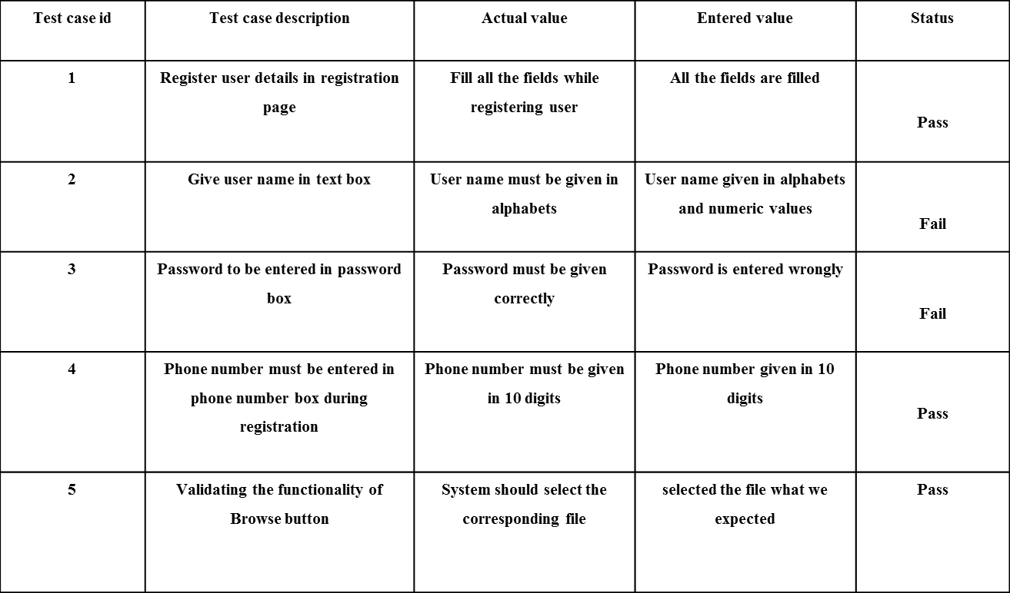

Fig 5.10: Testcase Template

Test Results: All the test cases stated above passed effectively. No defects met.

#!/usr/bin/env python3 """
NaptProxy - A Python-based proxy server for intercepting and analyzing vulnerability scanner traffic
"""

import os import sys import logging

import threading import argparse
from proxy_server import ProxyServer

from web_interface import app, start_web_interface, set_proxy_server

# Set up logging logging.basicConfig(
level=logging.INFO,

format='%(asctime)s - %(name)s - %(levelname)s - %(message)s', handlers=[
logging.FileHandler("naptyproxy.log"), logging.StreamHandler(sys.stdout)
]

)

logger = logging.getLogger("NaptProxy")

def parse_arguments():

"""Parse command line arguments"""

parser = argparse.ArgumentParser(description='NaptProxy - A vulnerability scanner traffic proxy server')

# Proxy configuration

parser.add_argument('--proxy-host', type=str, default='0.0.0.0', help='Host for the proxy server (default: 0.0.0.0)')
parser.add_argument('--proxy-port', type=int, default=8000, help='Port for the proxy server (default: 8000)')

# Web interface configuration

parser.add_argument('--web-host', type=str, default='0.0.0.0', help='Host for the web interface (default: 0.0.0.0)')
parser.add_argument('--web-port', type=int, default=5000, help='Port for the web interface (default: 5000)')

# Logging configuration

parser.add_argument('--log-level', type=str, choices=['DEBUG', 'INFO', 'WARNING', 'ERROR', 'CRITICAL'],
default='INFO', help='Set the logging level (default: INFO)') parser.add_argument('--log-file', type=str, default='naptyproxy.log',
help='File to save logs (default: naptyproxy.log)')

# SSL interception

parser.add_argument('--intercept-ssl', action='store_true',

help='Enable SSL/TLS interception (requires CA certificate)') parser.add_argument('--ca-cert', type=str, default='ca/ca.crt',
help='Path to CA certificate (default: ca/ca.crt)') parser.add_argument('--ca-key', type=str, default='ca/ca.key',
help='Path to CA private key (default: ca/ca.key)')

# Advanced options

parser.add_argument('--buffer-size', type=int, default=8192, help='Socket buffer size in bytes (default: 8192)')
parser.add_argument('--timeout', type=int, default=60, help='Socket timeout in seconds (default: 60)')
parser.add_argument('--max-connections', type=int, default=100, help='Maximum number of concurrent connections (default: 100)')

return parser.parse_args()

# Create and configure proxy server with default settings # This instance will be used when running with Gunicorn default_proxy = ProxyServer(
host='0.0.0.0',

port=8000,

buffer_size=8192, timeout=60, max_connections=100, intercept_ssl=False, ca_cert='ca/ca.crt', ca_key='ca/ca.key'
)

# Start the proxy server in a thread

proxy_thread = threading.Thread(target=default_proxy.start) proxy_thread.daemon = True
proxy_thread.start()

# Set the proxy server instance in the Flask app and get the configured app app = set_proxy_server(default_proxy)

if name == " main ": args = parse_arguments()

# Set log level based on arguments log_level = getattr(logging, args.log_level)

logging.basicConfig(level=log_level)

# Create and configure proxy server with command line arguments proxy_server = ProxyServer(
host=args.proxy_host, port=args.proxy_port, buffer_size=args.buffer_size, timeout=args.timeout, max_connections=args.max_connections, intercept_ssl=args.intercept_ssl, ca_cert=args.ca_cert, ca_key=args.ca_key
)

# Start proxy server in a separate thread

proxy_thread = threading.Thread(target=proxy_server.start) proxy_thread.daemon = True
proxy_thread.start()

logger.info(f"Proxy server started on {args.proxy_host}:{args.proxy_port}")

# Start web interface (this will block) start_web_interface(args.web_host, args.web_port, proxy_server)

% extends 'layout.html' %}

{% block title %}Dashboard{% endblock %}

{% block header %}Dashboard{% endblock %}

{% block header_buttons %}

<div class="btn-group me-2">

<button type="button" class="btn btn-sm btn-outline-secondary" id="refresh-dashboard">

<i data-feather="refresh-cw"></i> Refresh

</button>

</div>

{% endblock %}

{% block content %}

<div class="row">

<!-- Overview Cards -->

<div class="col-md-3 mb-4">

<div class="card bg-dark text-white h-100">

<div class="card-body">

<h5 class="card-title"><i data-feather="server" class="text-info"></i> Proxy
Status</h5>

<div class="mt-3">

<div class="d-flex justify-content-between">

<span>Status</span>

<span id="status-badge" class="badge bg-success">Running</span>

</div>

<div class="d-flex justify-content-between mt-2">

<span>Uptime</span>

<span id="dashboard-uptime">0s</span>

</div>

<div class="d-flex justify-content-between mt-2">

<span>Requests/sec</span>

<span id="requests-per-second">0</span>

</div>

<div class="d-flex justify-content-between mt-2">

<span>Active Connections</span>

<span id="active-connections">0</span>

</div>

</div>

</div>

</div>

</div>

<div class="col-md-3 mb-4">

<div class="card bg-dark text-white h-100">

<div class="card-body">

<h5 class="card-title"><i data-feather="activity" class="text-info"></i>
Traffic</h5>

<div class="mt-3">

<div class="d-flex justify-content-between">

<span>Total Requests</span>

<span id="dash-total-requests">0</span>

</div>

<div class="d-flex justify-content-between mt-2">

<span>Total Responses</span>

<span id="total-responses">0</span>

</div>

<div class="d-flex justify-content-between mt-2">

<span>Data In</span>

<span id="dash-total-bytes-in">0 B</span>

</div>

<div class="d-flex justify-content-between mt-2">

<span>Data Out</span>

<span id="dash-total-bytes-out">0 B</span>

</div>

</div>

</div>

</div>

</div>

<div class="col-md-3 mb-4">

<div class="card bg-dark text-white h-100">

<div class="card-body">

<h5 class="card-title"><i data-feather="shield" class="text-info"></i> Security</h5>
<div class="mt-3">

<div class="d-flex justify-content-between">

<span>SSL Interception</span>

<span id="ssl-interception" class="badge bg-secondary">Disabled</span>

</div>

<div class="d-flex justify-content-between mt-2">

<span>Total Vulnerabilities</span>

<span id="total-vulnerabilities">0</span>

</div>

<div class="d-flex justify-content-between mt-2">

<span>Scanner Signatures</span>

<span id="scanner-signatures">0</span>

</div>

</div>

</div>

</div>

</div>

<div class="col-md-3 mb-4">

<div class="card bg-dark text-white h-100">

<div class="card-body">

<h5 class="card-title"><i data-feather="settings" class="text-info"></i> Configuration</h5>
<div class="mt-3">

<div class="d-flex justify-content-between">

<span>Proxy Address</span>

<span id="dash-proxy-address">0.0.0.0:8000</span>

</div>

<div class="d-flex justify-content-between mt-2">

<span>Web Interface</span>

<span id="web-interface">0.0.0.0:5000</span>

</div>

<div class="d-flex justify-content-between mt-2">

<span>Log Level</span>

<span id="log-level">INFO</span>

</div>

</div>

<div class="mt-3">

<a href="/settings" class="btn btn-outline-info btn-sm w-100">Settings</a>

</div>

</div>

</div>

</div>

</div>

<div class="row">

<!-- Traffic Charts -->

<div class="col-md-6 mb-4">

<div class="card bg-dark text-white">

<div class="card-body">

<h5 class="card-title">Request Methods</h5>

<div class="chart-container" style="position: relative; height: 200px;">

<canvas id="request-methods-chart"></canvas>

</div>

</div>

</div>

</div>

<div class="col-md-6 mb-4">

<div class="card bg-dark text-white">

<div class="card-body">

<h5 class="card-title">Response Codes</h5>

<div class="chart-container" style="position: relative; height: 200px;">

<canvas id="response-codes-chart"></canvas>

</div>

</div>

</div>

</div>

</div>

<div class="row">

<!-- Vulnerability Detections -->

<div class="col-md-12 mb-4">

<div class="card bg-dark text-white">

<div class="card-body">

<h5 class="card-title">Vulnerability Detections</h5>

<div class="chart-container" style="position: relative; height: 200px;">

<canvas id="vulnerabilities-chart"></canvas>

</div>

</div>

</div>

</div>

</div>

<div class="row">

<!-- Recent Transactions -->

<div class="col-md-12 mb-4">

<div class="card bg-dark text-white">

<div class="card-body">

<h5 class="card-title">Recent Transactions</h5>

<div class="table-responsive">

<table class="table table-dark table-hover">

<thead>

<tr>

<th>Time</th>

<th>Client</th>

<th>Method</th>

<th>URL</th>

<th>Status</th>

<th>Size</th>

<th>Vulnerabilities</th>

</tr>

</thead>

<tbody id="recent-transactions">

<tr>

<td colspan="7" class="text-center">No transactions recorded yet</td>

</tr>

</tbody>

</table>

</div>

<div class="text-end mt-3">

<a href="/logs" class="btn btn-outline-info btn-sm">View All Logs</a>

</div>

</div>

</div>

</div>

</div>

{% endblock %}

{% block scripts %}

<script src="/static/js/dashboard.js"></script>

<script>

document.addEventListener('DOMContentLoaded', function() {

// Initialize dashboard with data initDashboard();

// Refresh button handler

document.getElementById('refresh-dashboard').addEventListener('click', function() { initDashboard();
});

// Auto-refresh every 10 seconds setInterval(initDashboard, 10000);
});

function initDashboard() {

// Fetch proxy status fetch('/api/status')
.then(response => response.json())

.then(data => { updateProxyStatus(data);
})

.catch(error => console.error('Error fetching proxy status:', error));

// Fetch traffic statistics fetch('/api/stats')
.then(response => response.json())

.then(data => { updateTrafficStats(data); updateCharts(data);
})

.catch(error => console.error('Error fetching traffic stats:', error));

// Fetch vulnerabilities fetch('/api/vulnerabilities')
.then(response => response.json())

.then(data => { updateVulnerabilityStats(data);
})

.catch(error => console.error('Error fetching vulnerabilities:', error));

// Fetch recent transactions fetch('/api/transactions?limit=10')
.then(response => response.json())

.then(data => { updateRecentTransactions(data.transactions);
})

.catch(error => console.error('Error fetching transactions:', error));

}

function updateProxyStatus(data) {

// Update status badge

const statusBadge = document.getElementById('status-badge');

if (data.running) {

statusBadge.className = 'badge bg-success'; statusBadge.textContent = 'Running';
} else {

statusBadge.className = 'badge bg-danger'; statusBadge.textContent = 'Stopped';
}

// Update SSL interception status

const sslBadge = document.getElementById('ssl-interception'); if (data.intercept_ssl) {
sslBadge.className = 'badge bg-success'; sslBadge.textContent = 'Enabled';
} else {

sslBadge.className = 'badge bg-secondary'; sslBadge.textContent = 'Disabled';
}

// Update connections

document.getElementById('active-connections').textContent = data.connections;

// Update proxy address

document.getElementById('dash-proxy-address').textContent =
`${data.host}:${data.port}`;

}

function updateTrafficStats(data) {

document.getElementById('dash-total-requests').textContent = data.total_requests; document.getElementById('total-responses').textContent = data.total_responses;
document.getElementById('dash-total-bytes-in').textContent = formatBytes(data.total_bytes_in);
document.getElementById('dash-total-bytes-out').textContent = formatBytes(data.total_bytes_out);
document.getElementById('dashboard-uptime').textContent = formatDuration(data.uptime);
document.getElementById('requests-per-second').textContent = data.requests_per_second.toFixed(2);
}

function updateVulnerabilityStats(data) { let totalVulns = 0;
let scannerSigs = 0;

// Sum all vulnerability types

for (const vuln in data) {

totalVulns += data[vuln].total_matches; if (vuln === 'scanner_signatures') {
scannerSigs = data[vuln].total_matches;

}

}

document.getElementById('total-vulnerabilities').textContent = totalVulns; document.getElementById('scanner-signatures').textContent = scannerSigs;
}

function updateRecentTransactions(transactions) {

const tableBody = document.getElementById('recent-transactions');

if (transactions.length === 0) {

tableBody.innerHTML = '<tr><td colspan="7" class="text-center">No transactions recorded yet</td></tr>';
return;

}

let html = '';

transactions.forEach(tx => {

const time = new Date(tx.timestamp * 1000).toLocaleTimeString(); const client = tx.client_address;
const method = tx.request.method || 'Unknown'; const url = tx.request.url || 'Unknown';
const status = tx.response.status_code || '-'; const size = formatBytes(tx.response.size || 0);

// Count vulnerabilities

const vulnCount = tx.vulnerabilities.length; const vulnBadge = vulnCount > 0
? `<span class="badge bg-danger">${vulnCount}</span>`

: '<span class="badge bg-secondary">0</span>';

html += `

<tr>

<td>${time}</td>

<td>${client}</td>

<td>${method}</td>

<td class="text-truncate" style="max-width: 200px;">${url}</td>

<td>${status}</td>

<td>${size}</td>

<td>${vulnBadge}</td>

</tr>

`;

});

tableBody.innerHTML = html;

}

</script>

{% endblock %}

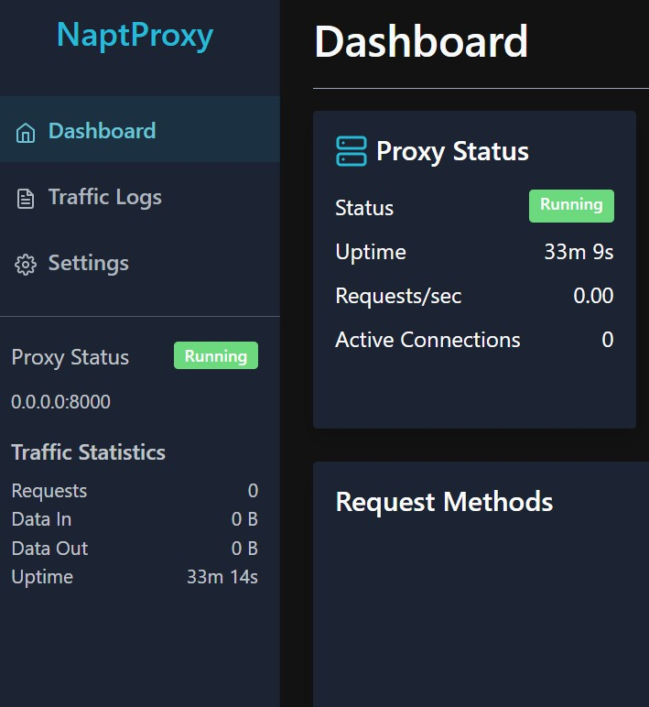

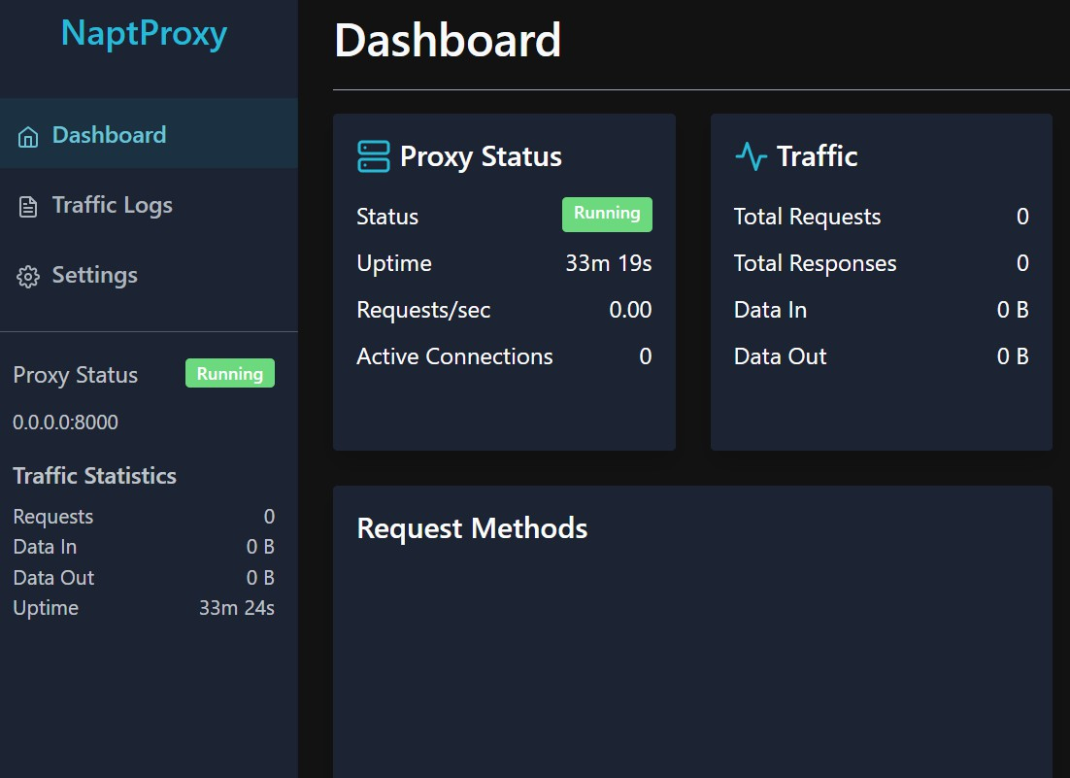

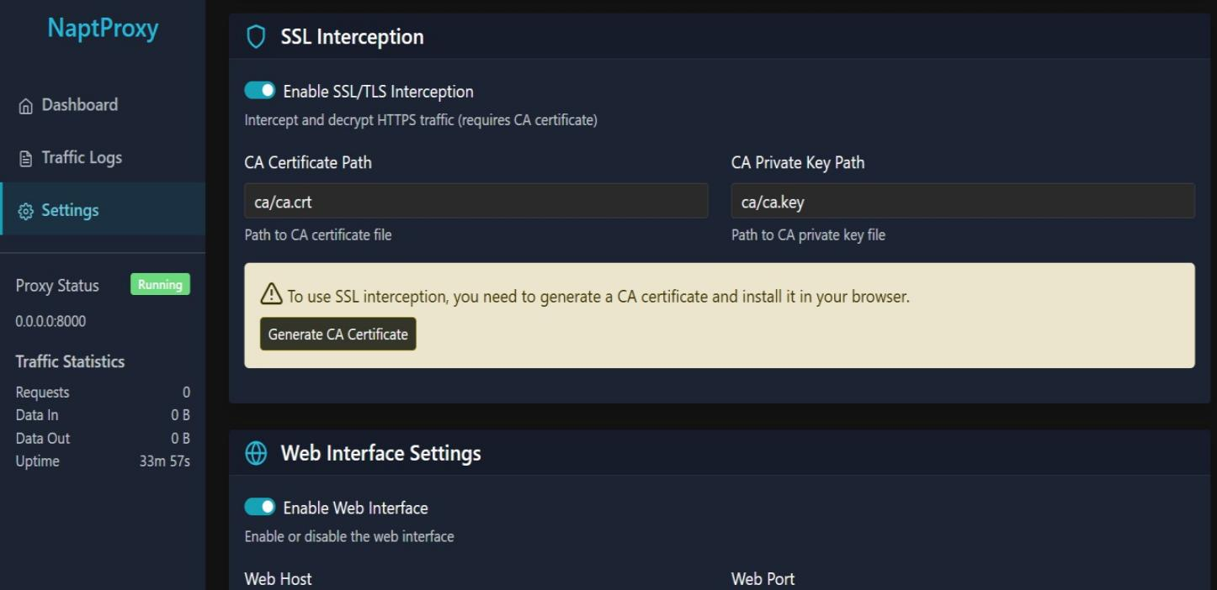

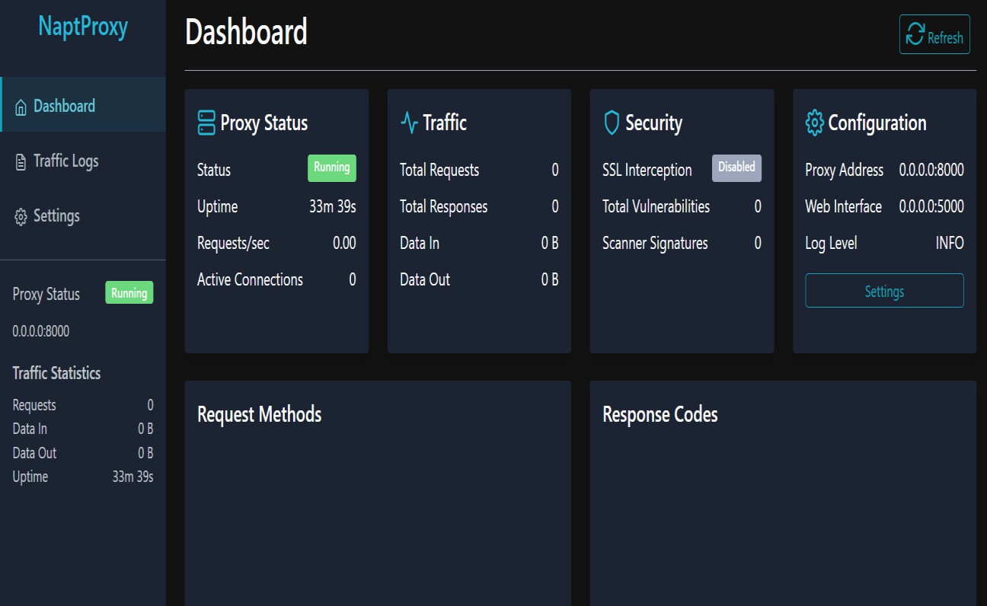

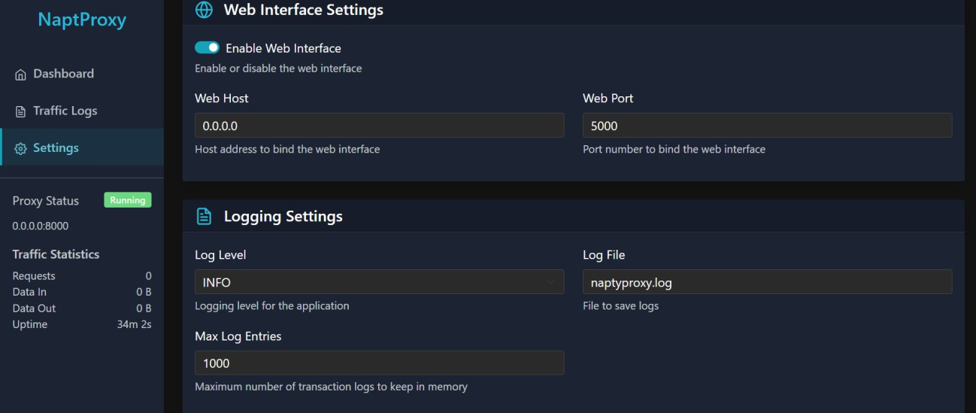

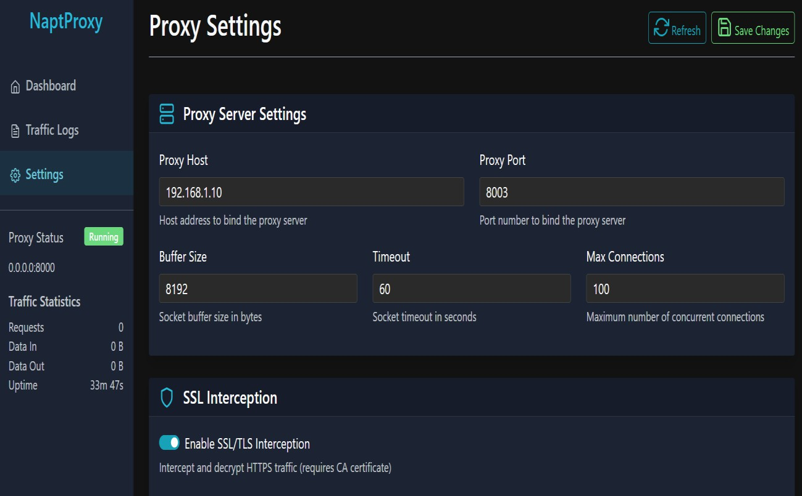

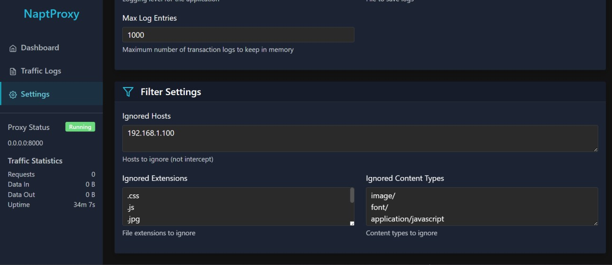
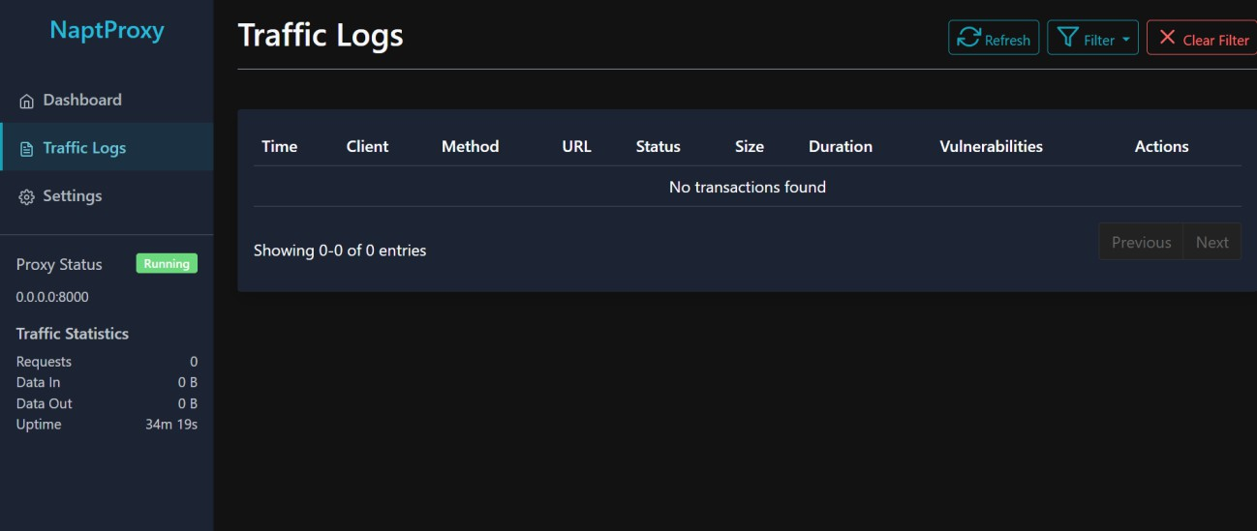

  - OUT SCREENS

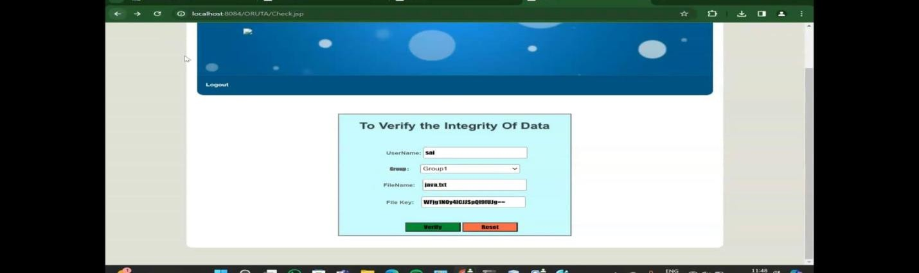
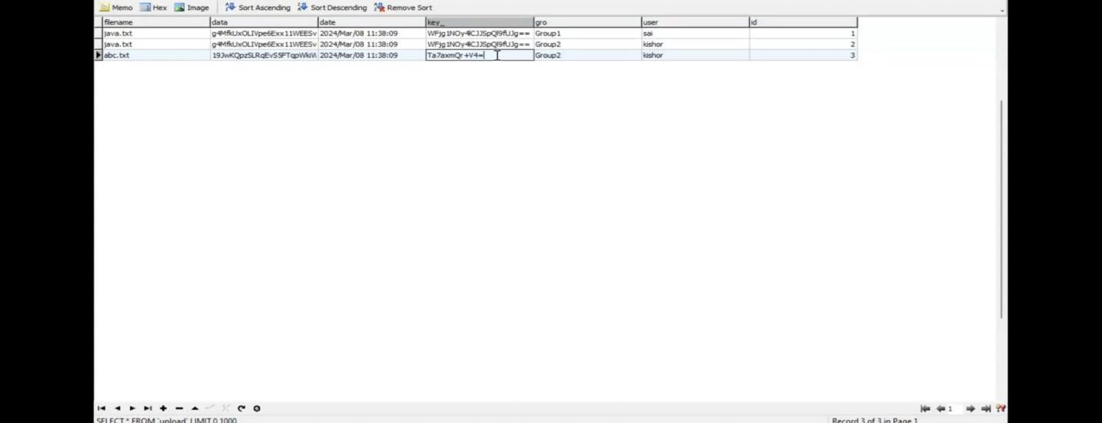



CHAPTER 7

CONCLUSION

FEATURE ENHANCEMET

In this paper, we propose Oruta, a privacy-preserving public auditing mechanism for shared data in the cloud. We utilize ring signatures to construct homomorphic authenticators, so that a public verifier is able to audit shared data integrity without retrieving the entire data, yet it cannot distinguish who is the signer on each block. To improve the efficiency of verifying multiple auditing tasks, we further extend our mechanism to support batch auditing. There are two interesting problems we will continue to study for our future work. One of them is traceability, which means the ability for the group manager (i.e., the original user) to reveal the identity of the signer based on verification metadata in some special situations. Since Oruta is based on ring signatures, where the identity of the signer is unconditionally protected [21], the current design of ours does not support traceability. To the best of our knowledge, designing an efficient public auditing mechanism with the capabilities of preserving identity privacy and supporting traceability is still open. Another problem for our future work is how to prove data freshness (prove the cloud possesses the latest version of shared data) while still preserving identity privacy.

CHAPTER 8

REFERENCES
Good Teachers are worth more than thousand books, we have them in Our Department

REFERENCES
- B. Wang, B. Li, and H. Li, “Oruta: Privacy-Preserving Public Auditing for Shared Data in the Cloud,” Proc. IEEE Fifth Int’l Conf. Cloud Computing, pp. 295-302, 2012.
- M. Armbrust, A. Fox, R. Griffith, A.D. Joseph, R.H. Katz, A. Konwinski, G. Lee, D.A. Patterson, A. Rabkin, I. Stoica, and M. Zaharia, “A View of Cloud Computing,” Comm. ACM, vol. 53, no. 4, pp. 50-58, Apr. 2010.
- K. Ren, C. Wang, and Q. Wang, “Security Challenges for the Public Cloud,” IEEE Internet Computing, vol. 16, no. 1, pp. 69-73, 2012.
- D. Song, E. Shi, I. Fischer, and U. Shankar, “Cloud Data Protection for the Masses,” Computer, vol. 45, no. 1, pp. 39-45, 2012.
- C. Wang, Q. Wang, K. Ren, and W. Lou, “Privacy-Preserving Public Auditing for Data Storage Security in Cloud Computing,” Proc. IEEE INFOCOM, pp. 525-533, 2010.
- B. Wang, M. Li, S.S. Chow, and H. Li, “Computing Encrypted Cloud Data Efficiently under Multiple Keys,” Proc. IEEE Conf. Comm. and Network Security (CNS ’13), pp. 90-99, 2013.
- R. Rivest, A. Shamir, and L. Adleman, “A Method for Obtaining Digital Signatures and Public Key Cryptosystems,” Comm. ACM, vol. 21, no. 2, pp. 120-126, 1978.
- The MD5 Message-Digest Algorithm (RFC1321). https://tools. ietf.org/html/rfc1321, 2014.
- G. Ateniese, R. Burns, R. Curtmola, J. Herring, L. Kissner, Z. Peterson, and D. Song, “Provable Data Possession at Untrusted Stores,” Proc. 14th ACM Conf. Computer and Comm. Security (CCS ’07), pp. 598-610, 2007.
- H. Shacham and B. Waters, “Compact Proofs of Retrievability,” Proc. 14th Int’l Conf. Theory and Application of Cryptology and Information Security: Advances in Cryptology (ASIACRYPT ’08), pp. 90-107, 2008.

- C. Erway, A. Kupcu, C. Papamanthou, and R. Tamassia, “Dynamic Provable Data Possession,” Proc. 16th ACM Conf. Computer and Comm. Security (CCS’09), pp. 213-222, 2009.
- Q. Wang, C. Wang, J. Li, K. Ren, and W. Lou, “Enabling Public Verifiability and Data Dynamic for Storage Security in Cloud Computing,” Proc. 14th European Conf. Research in Computer Security (ESORICS’09), pp. 355-370, 2009.
- C. Wang, Q. Wang, K. Ren, and W. Lou, “Ensuring Data Storage Security in Cloud Computing,” Proc. 17th Int’l Workshop Quality of Service (IWQoS’09), pp. 1-
- B. Chen, R. Curtmola, G. Ateniese, and R. Burns, “Remote Data Checking for Network Coding-Based Distributed Storage Systems,” Proc. ACM Workshop Cloud Computing Security Workshop (CCSW’10), pp. 31-42, 2010.
- Y. Zhu, H. Wang, Z. Hu, G.-J. Ahn, H. Hu, and S.S Yau, “Dynamic Audit Services for Integrity Verification of Outsourced Storages in Clouds,” Proc. ACM Symp. Applied Computing (SAC’11), pp. 1550-1557, 2011.
- N. Cao, S. Yu, Z. Yang, W. Lou, and Y.T. Hou, “LT Codes-Based Secure and Reliable Cloud Storage Service,” Proc. IEEE INFOCOM, 2012.
- B. Wang, B. Li, and H. Li, “Certificateless Public Auditing for Data Integrity in the Cloud,” Proc. IEEE Conf. Comm. and Network Security (CNS’13), pp. 276-284, 2013.
- C. Wang, S.S. Chow, Q. Wang, K. Ren, and W. Lou, “Privacy-Preserving Public Auditing for Secure Cloud Storage,” IEEE Trans. Computers, vol. 62, no. 2, pp. 362-375, Feb. 2013.
- B. Wang, B. Li, and H. Li, “Public Auditing for Shared Data with Efficient User Revocation in the Cloud,” Proc. IEEE INFOCOM, pp. 2904-2912, 2013.
- B. Wang, B. Li, and H. Li, “Panda: Public Auditing for Shared Data with Efficient User Revocation in the Cloud,” IEEE Trans. Services Computing, 20 Dec. 2013, DOI: 10.1109/TSC.2013.2295611. [21] D. Boneh, C. Gentry, B. Lynn, and H. Shacham, “Aggregate and Verifiably Encrypted Signatures from Bilinear Maps,” Proc. 22nd Int’l Conf. Theory and Applications of Cryptographic Techniques: Advances in Cryptology (EUROCRYPT’03), pp. 416- 432, 2003.

